Exploratory Data Analysis (EDA) Report

1. Dataset Overview
Rows: 1107, Columns: 19
import pandas as pd

# Load dataset
df = pd.read_excel("Data set.xlsx")
# Shape of dataset
print(df.shape)
# Show first 5 rows
print(df.head())

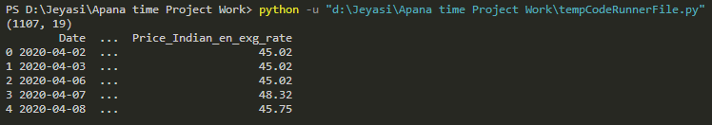
2.Data Cleaning
df['Date'] = pd.to_datetime(df['Date']).dt.floor('D')
print(df.dtypes)

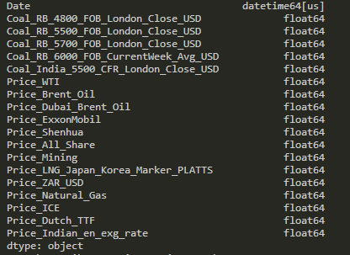

print(df.isnull().sum())

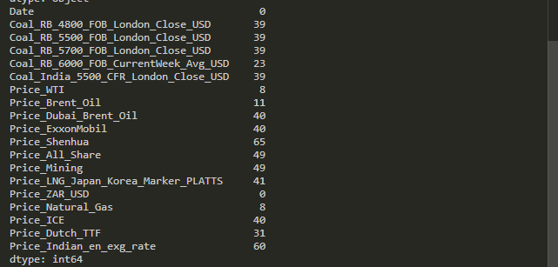
df.fillna(df.mean(numeric_only=True), inplace=True)
print(df.isnull().sum())

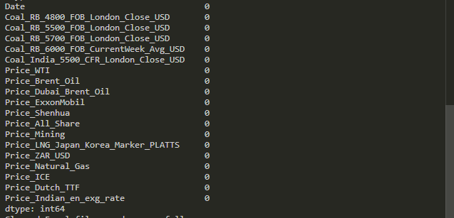
# Save cleaned dataset
df.to_excel("Cleaned_Data.xlsx", index=False)

print("Cleaned Excel file saved successfully")

2. Statistical Summary
a).Mean
import pandas as pd
df = pd.read_excel("Clean Data set.xlsx")
numeric_df = df.select_dtypes(include='number')
print("MEAN\n")
print(numeric_df.mean())

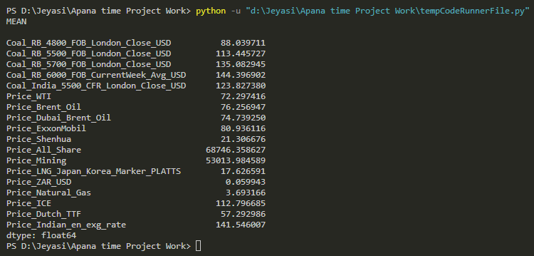

b).Median
import pandas as pd
df = pd.read_excel("Clean Data set.xlsx")
numeric_df = df.select_dtypes(include='number')
print("\nMEDIAN\n")
print(numeric_df.median())

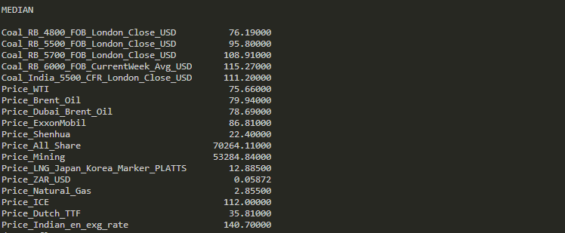

c).Mode
#c).Mode
import pandas as pd
df = pd.read_excel("Clean Data set.xlsx")
numeric_df = df.select_dtypes(include='number')
print("\nMODE\n" )
print(numeric_df.mode().iloc[0])

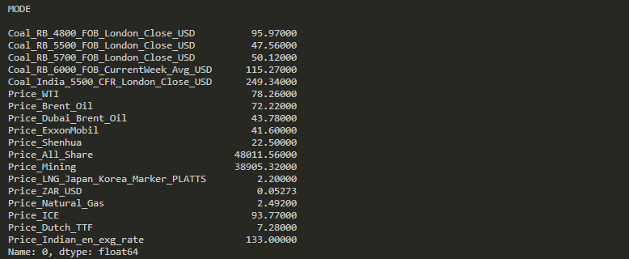

d).Variance
#d).Variance
import pandas as pd
df = pd.read_excel("Clean Data set.xlsx")
numeric_df = df.select_dtypes(include='number')
print("\nVARIANCE\n")
print(numeric_df.var())

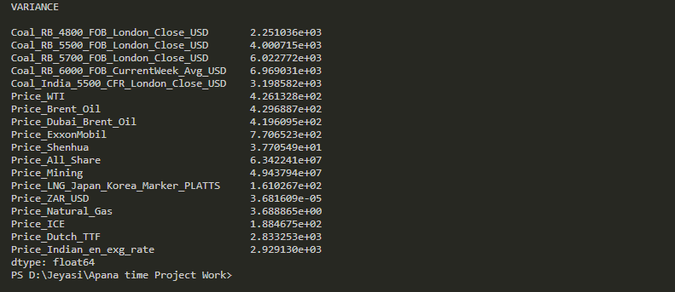

e).Standard Deviation
#e).Standard Deviation
import pandas as pd
df = pd.read_excel("Clean Data set.xlsx")
numeric_df = df.select_dtypes(include='number')
print("\nSTANDARD DEVIATION\n")
print(numeric_df.std())

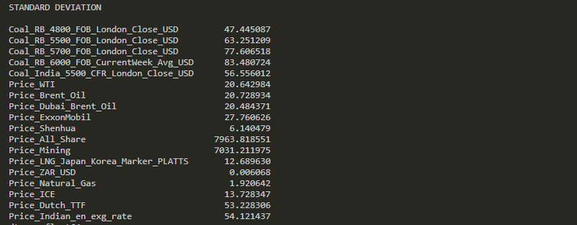

f).Range
#f).Range
import pandas as pd
df = pd.read_excel("Clean Data set.xlsx")
numeric_df = df.select_dtypes(include='number')
print("\nRANGE\n")
print(numeric_df.max() - numeric_df.min())

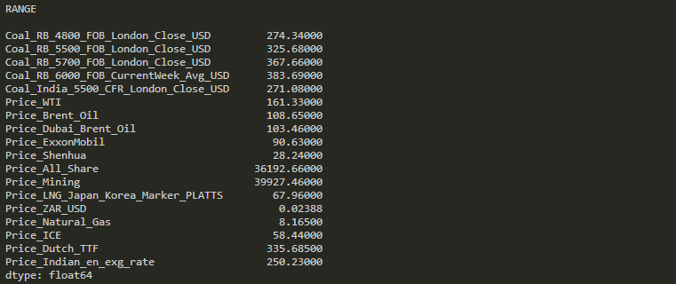
g).Skewness
#g).Skewness
import pandas as pd
df = pd.read_excel("Clean Data set.xlsx")
numeric_df = df.select_dtypes(include='number')
print("\nSKEWNESS\n")
print(numeric_df.skew())

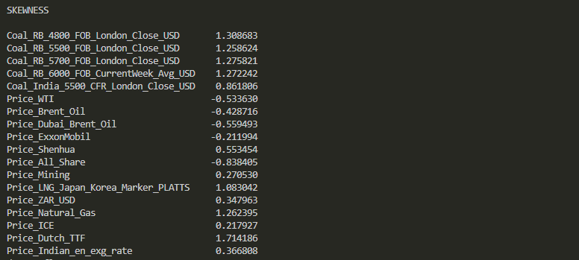
h). Kurtosis
#h). Kurtosis
import pandas as pd
df = pd.read_excel("Clean Data set.xlsx")
numeric_df = df.select_dtypes(include='number')
print("\nKURTOSIS\n")
print(numeric_df.kurt())

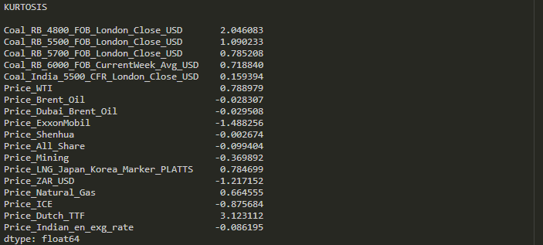
import pandas as pd

# Load dataset
df = pd.read_excel("Clean Data set.xlsx")

# Select numeric columns
numeric_df = df.select_dtypes(include='number')

# Dataset Shape
print("DATASET SHAPE")
print(df.shape)

# Mean
print("\nMEAN\n")
print(numeric_df.mean().round(2))

# Median
print("\nMEDIAN\n")
print(numeric_df.median().round(2))

# Mode
print("\nMODE\n")
print(numeric_df.mode())

# Variance
print("\nVARIANCE\n")
print(numeric_df.var().round(2))

# Standard Deviation
print("\nSTANDARD DEVIATION\n")
print(numeric_df.std().round(2))

# Range
print("\nRANGE\n")
print((numeric_df.max() - numeric_df.min()).round(2))

# Skewness
print("\nSKEWNESS\n")
print(numeric_df.skew().round(2))

# Kurtosis
print("\nKURTOSIS\n")
print(numeric_df.kurt().round(2))

# Unique values count
print("\nUNIQUE VALUES\n")
print(numeric_df.nunique())

# Create results DataFrame
results = pd.DataFrame()

# Measures of Central Tendency
results["Mean"] = numeric_df.mean()
results["Median"] = numeric_df.median()
results["Mode"] = numeric_df.mode().iloc[0]

# Measures of Dispersion
results["Variance"] = numeric_df.var()
results["Standard Deviation"] = numeric_df.std()
results["Range"] = numeric_df.max() - numeric_df.min()

# Skewness and Kurtosis
results["Skewness"] = numeric_df.skew()
results["Kurtosis"] = numeric_df.kurt()

# Convert index into column names
results.reset_index(inplace=True)
results.rename(columns={"index": "Column"}, inplace=True)

# Display results
print(results)

# Save results to Excel
results.to_excel("Statistical_Analysis_Output.xlsx", index=False)

print("\nStatistical analysis saved successfully!")
